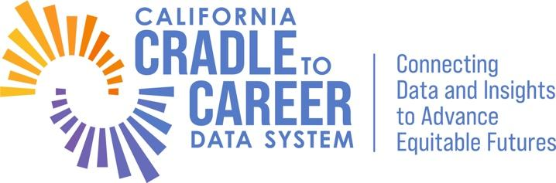
Cradle-to-Career Data and Tools Advisory Board Proposal Form

Instructions:
Per the Governance Manual proposal forms submitted will address significant gaps regarding whether the data system is providing access to actionable information. Please note there should only be one proposal per form.

Name:

Proposal Title: no more than 50 characters

Type of Proposal:
- Changes to practical tools for students (Complete section one)
- Adding data points not available through the P20W data set or adjusting (including the removal of) the existing P20W data points (Complete section two)
- Please note a proposal form(s) can recommend adding one data point or several clearly related data points to the data system.

Section One: Changes to Practical Tools
1.What is the nature of the gap regarding access to actionable information?

2. What type of tool should be developed?

3. How would a tool address the gap?

4. Who would be the likely user(s) of the tool?

5. How does the tool relate to the mission and vision of C2C?

Section Two: Adding Data Points Not Available Through the P20W Data Set or Adjusting the Existing P20W Data Points
1.Please state the research question of interest that cannot be fully addressed with the existing data elements in the P20W Data System.

2. How does this research question relate to the mission and vision of C2C?

3. Please propose additional data element(s) needed in order to successfully address the research question of interest.

4. Please verify that the proposed data element(s) do not already exist in the P20W Data System.

5. If the P20W Data System does not currently include the proposed data element(s), can the proposed data element(s) be derived from the existing data element(s) in the P20W Data System?

6. If the P20W Data System does not currently include the proposed data element(s), are there existing data element(s) closely related to the proposed data element(s)? If so, please list them and why they are not sufficient to answer the proposed research question.

7. C2C keeps a repository of previous data elements that were either a) considered during the planning process or b) proposed through the mechanisms as outlined in the Governance Manual, but were ultimately not included in the P20W, along with related feasibility studies. Do any of the data element(s) being proposed overlap with the data elements in this repository? (New proposals can build on or duplicate prior proposals. It is helpful for proposers to share that context, including prior related feasibility studies.)

8. Are the proposed data element(s) already collected by a state-level entity? For data element(s) already collected, please answer question nine. For data element(s) not collected, please answer question ten.

9. [For proposed data element(s) already collected] To the extent possible, please share details pertaining to the proposed data element(s). Relevant details may include but are not limited to: a) corresponding entity that collects and houses the data element(s); b) specific variable name(s) used in the originating data system; and c) timeframe available.

10. [For proposed data element(s) not collected] Please propose institution(s) that would be most suited for the new data collection effort.

11. Please explain the desired level(s) of grain size for each data element proposed. (i.e., individual-level, institution-level, or other aggregated levels)? Multiple grain sizes may be requested for each proposed data element.

12. Please explain the intended use case(s) for the proposed data elements (i.e., dashboards, query builder, or the research request tool)? Multiple use cases may be requested for each proposed data element.

The C2C Governance Manual notes that DTAB members can also submit recommendations related to the data request process and changes to tools such as dashboards. As the data request process and the dashboards are not yet live, those sections have been removed from the 2024 version of this form.

