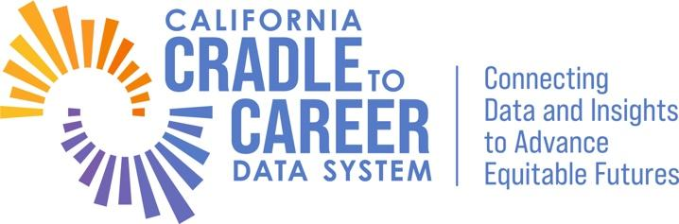
Community Engagement Advisory Board Proposal Form

Instructions:
Per the Governance Manual proposal forms submitted will address significant gaps regarding feedback loops with data users, evidence-based decision making and analytical capacity, and equitable access to actionable information. Please note there should only be one proposal per form.

Name:

Proposal Title: no more than 50 characters

- By checking this box, I understand that I will be presenting my recommendation at the Fall Advisory Board meeting.

Nature of Proposal:
- Feedback loops with data users
- Evidence-based decision making and analytical capacity
- Equitable access to actionable information

What action should be taken to address the issue?

Who could benefit from this action?

Who would implement this action?

How does the action relate to the mission and vision of C2C?

